Dialogue For Diversity

Minutes of the Annual General Meeting

14 Aug 2014 at 11.00 a.m.

At 28 Brookvale Avenue, Belfast, BT14 6BW

Present: Alan McGuckian (Chair), Terry Howard, Pat Davis

1. Minutes: The minutes of the 2013 AGM were approved
Proposed: Terry Howard; seconded: Pat Davis

2. Appointment of Director
Kate Martin and Padraig O’Connor were re-appointed as Directors for the coming year.
Proposed: Terry Howard; seconded: Pat Davis

3. Appointment of Management Committee
The following were appointed as members of the Management Committee:
- Brendan McPartlin
- Michael Bingham
- Kate Martin
- Frank Brady
- Brian Lennon
Proposed: Terry Howard; seconded: Pat Davis

4. Treasurer’s Report
- Accounts for the financial year have been approved by DMC Consultants, 8 Ashley Heights, Portadown BT61 1QE. A summary of the account are laid out below as Appendix One, and the full financial report as Appendix Two.
- The accounts were accepted:
Proposed Alan McGuckian, seconded Terry Howard

5. Chairman’s Report

Introduction
This has been a good year for the development of Dialogue For Diversity. We run four main projects: Migrants Support, Community Support for ex-prisoners, Dialogue between divided groups, and Community Development. Steady progress was made in all areas.

Community Support
We have seen more prisoners this year, both inside and outside prison and more individuals for a greater number of support sessions. This has been crucial in building the relationships that are at the core of our work.

We have continued to build on our very good relationships with prison staff in Magilligan and Maghaberry, with Probation and with other NGOs such as Quaker Support, the Methodist Prisoner Support Housing Project, De Paul Housing and Prison Fellowship. As well we have linked with Restorative Justice Ireland to support prisoners under threat. We were invited to speak at a conference on increasing volunteering in prisons organised by the Minister for Justice.

Organisationally 3 new volunteers joined us and we have a new Management Committee.

Our Volunteer meetings, held approximately monthly, have been key to developing our planning and strategy. They have also been central to our learning which came through sharing about our encounters with our mentees. Regular supervision was vital for each of us. Also important were the meetings we held with statutory and voluntary groups represented on our Advisory Committee.

As well, we have continued our relationship with Community Chaplaincy in London: this represents similar groups in England, Scotland, Wales and ourselves in Northern Ireland.

Mentees
One the hopes we expressed in last year’s Annual Report was that we would increase the number of people that we saw outside prison, and we have in fact been able to do this.

The following is an outline of the number of single and repeat visits that we made:

Total Visits | Individuals seen once | Individuals seen twice | Individuals seen three times | Individual  seen four times | Individualseen five times and over | Individual  Seen between 13 and 57 times | Total number of individuals seen
1156 | 156 | 49 | 16 | 10 | 32 | 19 | 183
Most important, in the above figures, are the 19 individuals who were seen between 13 and 57 times each. The fact that they are willing to meet us so often shows the continuing relationship that has been built with them and the trust that they have in our volunteers. They often thank us for our support. One intends to run the Dublin marathon to raise funds for the project. Many have multiple issues, and have been recurrent re-offenders for many years. Yet, only 6 are back inside. We continued to keep in touch with these. For many of the remainder their present period outside prison is the longest since they became teenagers.

The figures show that the project is – with many other individuals and groups – helping people to bring about the often very difficult change needed to avoid re-offending.

Geographically we met people in the Eastern half of Northern Ireland. There is an obvious need to extend the geographical remit of the project, especially in Derry/Londonderry.

The above figures give no indication of the real life in our encounters with each of these individuals. As well as meeting with mentees, we also attended court, spoke on behalf of a number, and wrote letters to judges on their behalf. On several occasions this led to a decision by the judge not to impose a custodial sentence.

One indicator of impact is the number who remained crime-free. Another is the increased time that they remain out of prison, and their willingness to continue the relationship with the project. This suggests that they are on the road to recovery, but this road is not a simple, clear journey with no diversions: it will involve the same ups and downs that the rest of us experience in our lives, and gradually – for many – lead to a new life without crime.

The following are some comments by our mentees:

`with the help of my mentor, who gave me sound advice and support, I began to find my feet. For the first time I years, I felt that someone trusted me. As time went on my confidence began to increase. Community Support have also visited my father, which has helped my father and me keep in touch. I would recommend Community Support to anyone returning the community’.

`To be honest, at the moment you’re the only one I can trust/have faith. You bring me good faith – as I said, you’re just like my grandfather’

`I have no way to express the depth of my appreciation that I feel for your time, patience, empathy and love with me’.

`me and **** had major bust up so dnt really care nie wat happens prison seems best place to be, cos out here ya never get a f***in break swear, sorry for telling you tjis
I know its just to hard I’m doing my best I dnt want to be fighting but sometimes it can’t be avoided and I’m the one to blame its not on
I’m at home now just calming myself, I won’t be making any rash decisions just gona stay in watch some football, its ok u dnt need to come to belfast, I wont let u dwn’.
Good relations
As a group drawn from a diverse background we hope to contribute to mainstreaming good relations in Northern Ireland. Most of the men we see come from working class areas with a high degree of segregation, and this can be one of the factors that lead them to crime. In prison they are exposed to people from diverse backgrounds, often something they cannot experience outside. We believe it is important that they are offered the same opportunities for good relations work as are people outside prison.

Referrals
Of those we saw outside we got referrals from PBNI, Chaplains, the Prison Service and Quaker Support. We made many referrals to housing, churches, especially to the Methodist Housing Support Scheme, De Paul housing, Cruse, Ad:Ept, Staurus (Milford), GPs, hostels, and above all to AA.

Many of our mentees brought great difficulties with them into prison: addictions – especially to prescribed drugs, a history of having been abused, chaotic family backgrounds, poor education and employment prospects, depression, etc. Many brought the same problems with them outside on release. If there is one way in which Community Support can help, it is by giving encouragement: this is one thing that prisoners desperately need. All of us have a past, but this does not mean that we cannot have a future. Believing this can be difficult for anyone. Given the circumstances of many prisoners it can be especially difficult for them.

Finance and fundraising
We received grants in this period from PBNI, the Methodist Church in Ireland, the Stephen’s Green Trust and the Big Lottery, and we are very grateful for these.

Migrant Support Service
The Migrant Support Service (MSS) has been working with local migrants from 2011. While largely staffed by voluntary workers there is one part time position for a Portuguese speaker as a migrant support worker which is crucial to the work. In 2013 we had no money for a paid worker but on foot of the Allen Lane Grant we re-employed our Support Worker from July onwards. A further small grant towards his salary was obtained from the Department of the First Minister (OFMDFM) for the year of 2014.

Information and Advice Service
The number of people who have come with issues since the beginning and who are on file is approximately 850. Each issue requires on average two or three visits. The number of face to face interviews held in the financial year 1913-14 was approximately 1,500. Many of the issues affect a number of people in the household and we estimate that perhaps 4,000 people were affected by our input.

Outreach Programme of the Portuguese Consulate
A surprise development was a request from the Portuguese Consul in Manchester to use our organisation to facilitate the consulate outreach programme to Portuguese citizens. Two people came from the consulate for three days on each of three occasions. Working intensively they dealt with about 300 people on each occasion on issues such as passports, citizen cards, registration of births and other issues. This is a useful service, and while it is the responsibility of the Consulate, it brings us into contact with the whole of the Portuguese speaking community of Northern Ireland. Three further outreach visits are scheduled for 2014.

Portuguese Consulate Outreach Programmes 2013-14

 | Nov  26-28th | Feb  24-26th | May  6-9th
Appointment list | 700 | 300 | 380
Passports |  |  | 42
Citizen Cards |  |  | 149
Birth Registrations | 150 |  | 50
Registration with embassy |  |  | 136
Other issues |  |  | 11
Attendance | 350 | 300 | 388

English Classes
Our English teaching facility grew in the past year with 107 people receiving certificates this month for having attended on average 80 hours of class and progressing through two levels (out of a total of six) of language learning. A difficulty here is that many more attend classes for shorter periods and then drop out. A good reason for dropping out is that many get work and move on. On the downside some are unmotivated because they are sent by Jobs and Benefits as a condition of receiving job seekers allowance. We need to discuss this with Jobs and Benefits and will meet them in July 2014.

The Neighbourhood Renewal programme of Craigavon Council is financing our rental of a classroom until June 2014. Following the amalgamation of three neighbouring councils the the new Super Council is not in a position to deal with the issue of our grant. We have secured rooms in a disused school for the coming year. They are outside the neighbourhood renewal area but are convenient for the majority of our students who live close to the centre of the town.

The Goal of Integration
An ultimate goal of this work is to build community among people, both migrant and indigenous. We have not carried out as many events towards this as originally envisaged. However, one has the impression that communication and mutual recognition is growing among many of us.

Work Placement
A local training agency that contracts with the Jobs and Benefits office placed one of their clients in our office where he has worked for almost a year as a receptionist. His development has been excellent in all aspects, language, rapport with clients, office skills etc so that his imminent departure will be a big loss.

Future Hope
The type of work that we are doing appears to fit with the policy of the Department of the First Minister who have been helpful with improving our organisational practice. This gives us hope that they will consider us as candidates for further grants in 2015 thus enabling us to carry on. Two salaries and the rental of an office and training room are deemed essential for sustainability in the long term.

3.2.3. Dialogue Project
During the year one residential was held to facilitate dialogue between Loyalists and Republicans. Much of it was taken up struggling with the past. But it was highly constructive. The listening among the divided groups was intense. Some Loyalist and ex-security force personnel found it difficult to listen to stories of collusion between the state and paramilitaries. But Republicans were struck by the degree to which they did listen. For their part Republicans learnt at first hand what it was like to be part of the security forces. A strong wish was expressed for more encounters, and that these would include more young people. These are planned for early 2015.

Members of DFD regularly attended Clergy Fraternals in Portadown and Armagh. These meetings are notable for the relaxed, informal atmosphere in which they now take, which is quite different from the tensions of the past.

3.2.4. Local community empowerment
We continued to support Drumcree Trust in Portadown and SPRING youth group in Armagh. Both are surviving in a difficult funding context. The work of SPRING has increased noticeably since their premises were renovated with a Neighbourhood Renewal Grant.

Church issues
We continue to support local church work in Portadown and Armagh. The justice commission in the Armagh Diocese initiated a survey of attitudes of people in Armagh and Louth to the RC church. While there were many criticisms many also wanted structural reforms and were appreciative about being consulted.

We continue to talk part in clergy groups in both areas.

Conclusion
The basic aim of Dialogue For Diversity is to develop more respect and esteem for all groups in society, especially among marginalized people. Clearly there is no end to this task. Nonetheless, the intiatives taken by the group over the past year have contributed to this end.

Minutes approved:

Alexander McGuckian, s.j.
Chair

Date:

Appendix 1: Financial summary
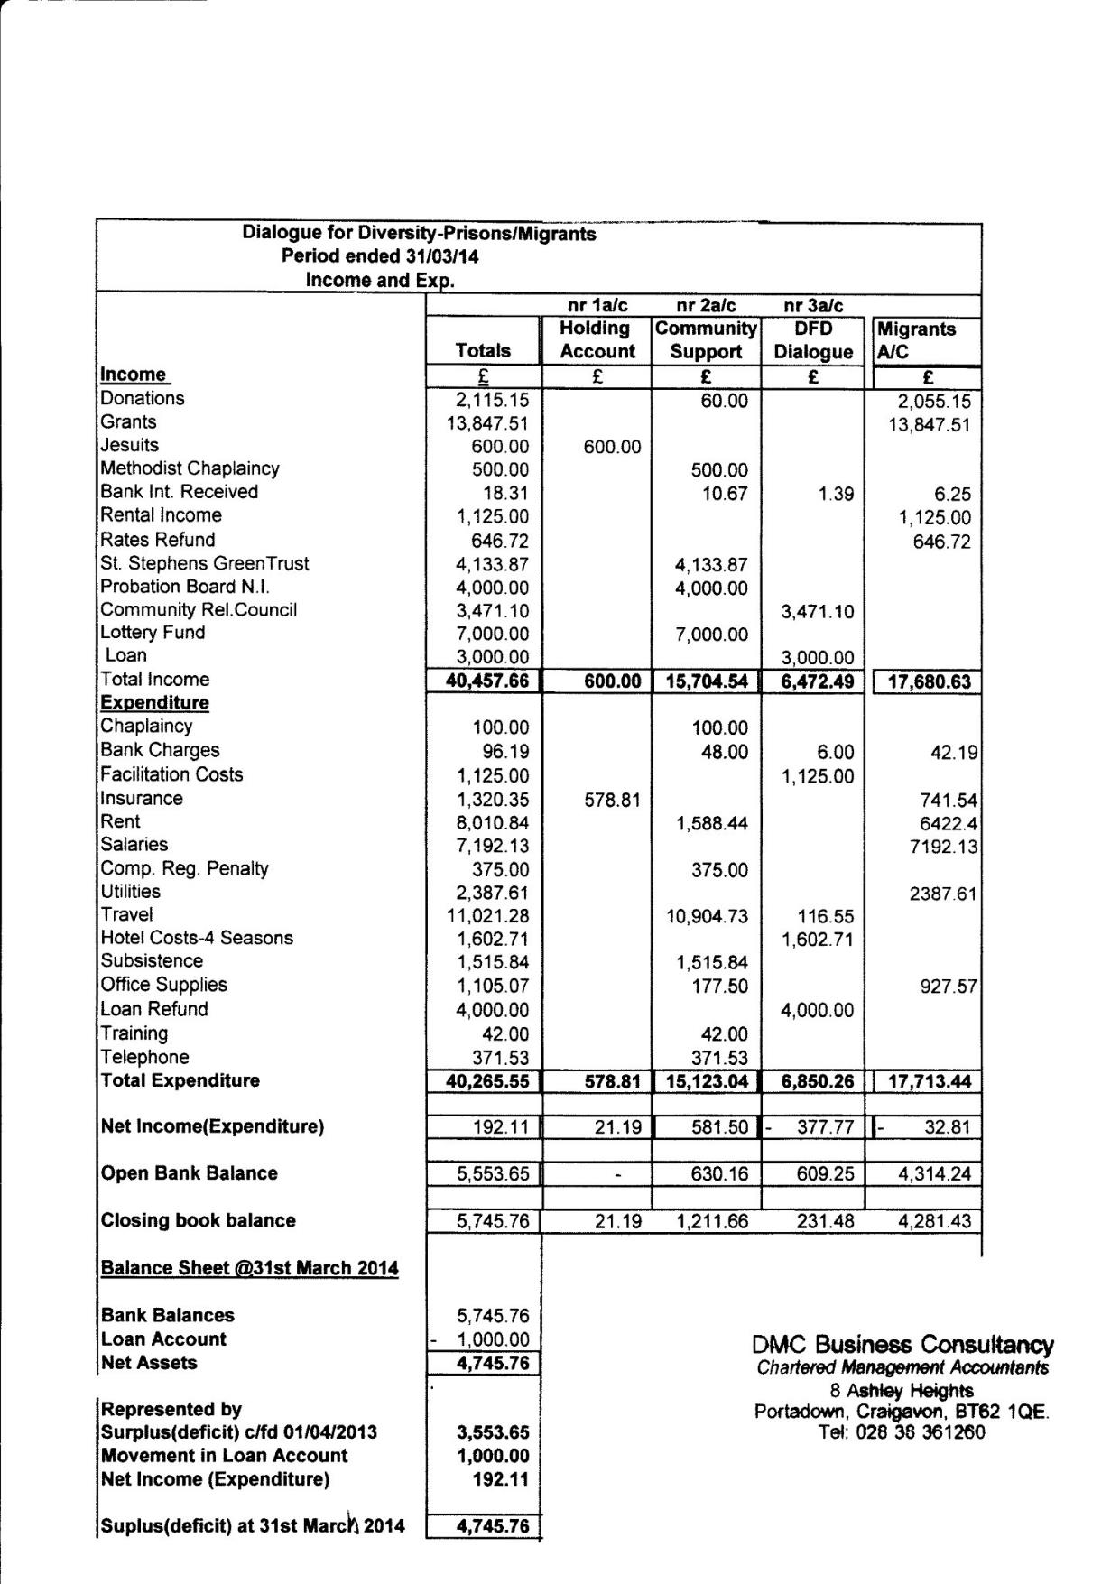
APPENDIX 2 ACCOUNTANT’S REPORT
